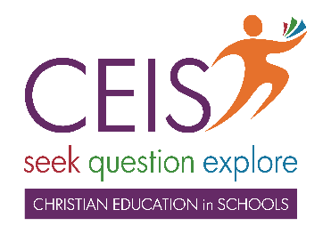

CEIS training is happening soon! Book into any session listed below & discover how you can help children explore God & Jesus.
Mon 22 May 12:30-2:30pm
Lifestream Christian Fellowship WANNIASSA
https://www.trybooking.com/CHVVF
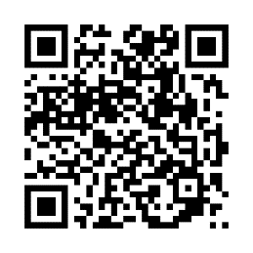
Tues 23 May 12:30-2:30pm
Hughes Baptist Church HUGHES
https://www.trybooking.com/CHVVL

Tues 23 May 5:00-7:00pm
Church of Christ AINSLIE
https://www.trybooking.com/CHVVN

Thousands of children are asking about God.
Will you take some time to tell them?

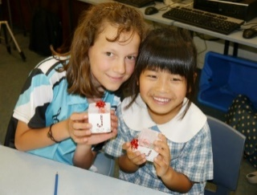
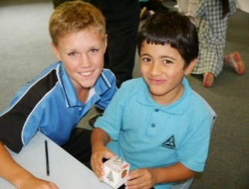
‘Jesus said, “Let the little children come to me, & do not hinder them,
for the kingdom of heaven belongs to such as these.”
Matthew 19:14

www.ceis.org.au coord@ceis.org.au ph: 6230 5155

CEIS training is happening soon! Book into any session listed below & discover how you can help children explore God & Jesus.
Mon 22 May 12:30-2:30pm
Lifestream Christian Fellowship WANNIASSA
https://www.trybooking.com/CHVVF
Tues 23 May 12:30-2:30pm
Hughes Baptist Church HUGHES
https://www.trybooking.com/CHVVL

Tues 23 May 5:00-7:00pm
Church of Christ AINSLIE
https://www.trybooking.com/CHVVN

Thousands of children are asking about God.
Will you take some time to tell them?

‘Jesus said, “Let the little children come to me, & do not hinder them,
for the kingdom of heaven belongs to such as these.”
Matthew 19:14

www.ceis.org.au coord@ceis.org.au ph: 6230 5155

